1. **Agenda**:
   1. We will explore the scenario where method reference can’t be used directly but refactoring the code will help us to use method reference.
2. 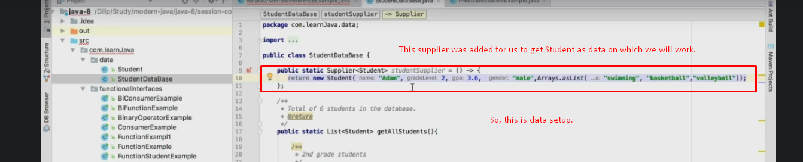
3. 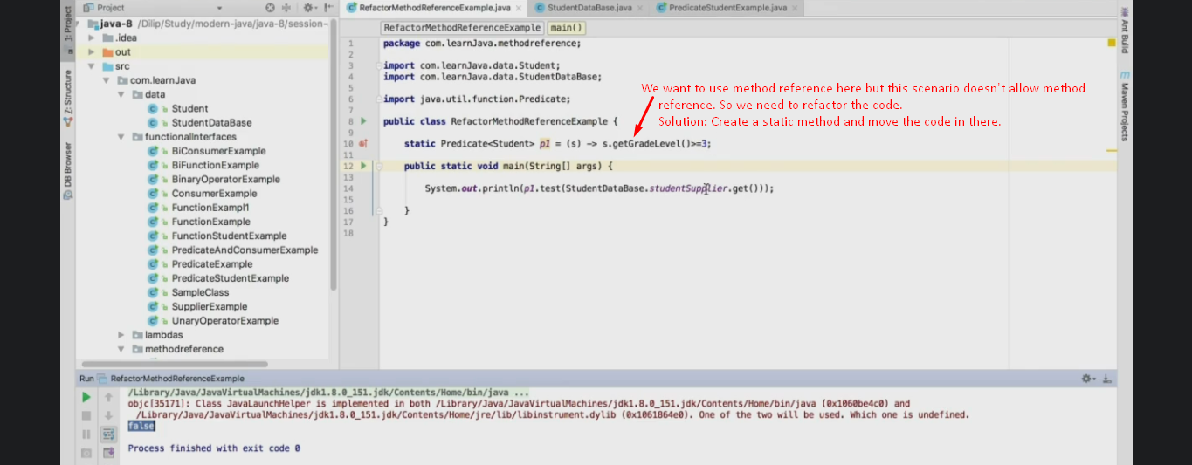
4. 